Spring Cleanup!

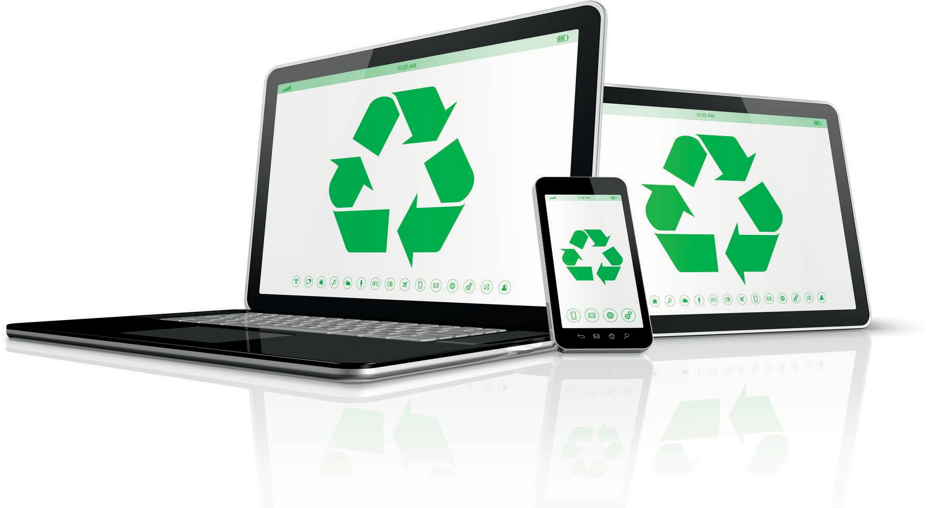Antwerp Township Presents-
Electronic Recycling Program for Antwerp, Almena, and Porter Township!
Every second Saturday of the month, starting May 13 and ending October 14. From 10:00AM to 2:00PM No Charge to residents of Antwerp, Almena, and Porter Township!
Location: Transfer station South Side of 64th Ave between CR 657 and 30th Street.

Accepted Items Non-Accepted Items
Computers/Laptops/Servers Consumer Electronics Smoke Detectors Printers/Scanners
- DVD Players/VCR's Glass/Paper
Cable Boxes/Routers -Audio Equipment Rubber
Mobile Devices & Tablets - Household Electronics Hazardous Waste
Networking Equipment CRT Monitor/Tv's Items Containing:
LCD Monitors LCD Tv's Liquid or Freon

